Five steps you can take to prevent falls | 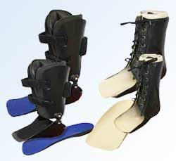  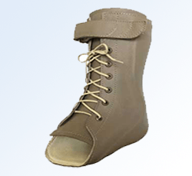  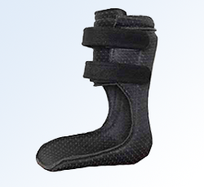
Begin a regular exercise program
Exercise is one of the most important ways to lower your chances of falling. Exercises that improve balance and coordination are most helpful. Lack of exercise leads to weakness and increases your chances of falling. Ask your doctor or health care provider about the best type of exercise program for you.
Review your medicines
Review all the medicines you take, even over the counter ones. With aging, the way medicines work in your body can change. Some medicines, or combinations of medicines, can make you sleepy or dizzy and can cause you to fall.
Have your feet checked
Painful feet can increase your chances of falling. Visit a podiatric physician (podiatrist) at least once a year for treatment of any foot or ankle pain and ask how to reduce your chances of falling.
Have your vision checked
Have your eyes checked by an eye doctor at least once a year. You may be wearing the wrong glasses or have a condition like glaucoma or cataracts that limits your vision. Poor vision can increase your chances of falling.
Make your home safer
About half of all falls happen at home. Remove things you can trip over (like papers, books, clothes, and shoes) from stairs and places where you walk. Remove small throw rugs and use double-sided tape to keep the rugs from slipping. Have grab bars put in next to your toilet and in the tub or shower. Use non-slip mats in the bathtub and on shower floors. As you get older, you need brighter lights to see well. Have handrails and lights put in on all staircases. Wear shoes both inside and outside the house. Avoid going barefoot or wearing slippers.
Fall Prevention Exercises  Heel slide  Increase leg strength to help with walking, transfers and stairs.  - Bend right knee and pull heel towards buttocks  - Slowly straighten knee  - Go slow.  - Complete a set with one leg then repeat with other leg.  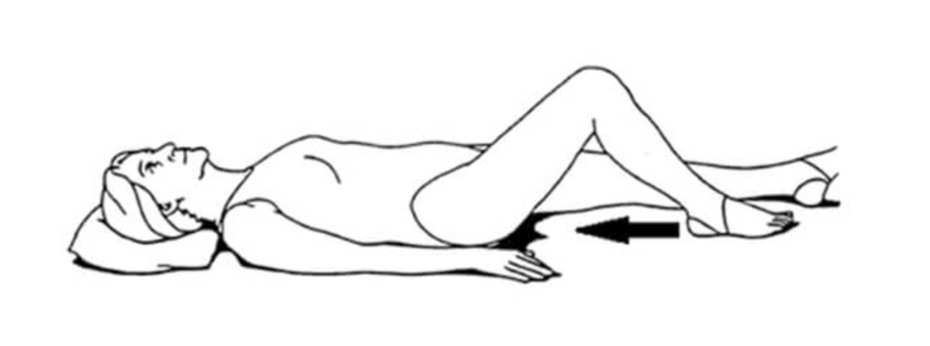  Hip abduction  Strengthens hip stabilizers which will help improve balance.  - Slide right leg out to the side  - Keep kneecap pointing toward ceiling  - Slowing bring leg back to middle  - Make sure leg barely lifts off the bed  - Complete a set of 10 with one leg then repeat with other leg.  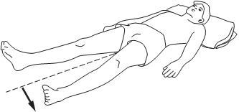 | Straight leg raise  Total leg workout that will assist with walking, transferring and especially with getting in and out of bed. Works muscles in stomach and back.  - Lie on bed, straighten right leg and place left foot flat.  - Raise right leg with knee locked.  - Lower right leg slower and do not allow to go all the way down to bed.  - Complete a set of 10 leg raises with one leg, then repeat with other leg.  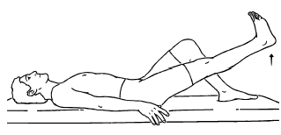  Bridging  Increases flexibility in waist area to assist with balance. Increase body awareness. Strengthens back, buttocks, and legs.  - Bend knees and place feet shoulder width apart.  - Lift hips up towards the ceiling.  - Hold for 3 seconds  - Return buttocks slowly to the ground. Do not let it drop.  - Repeat 10 times.  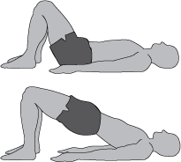

Toe raises  Most older adults are fearful of falling forward so they push backwards. This exercise helps them feel more comfortable leaning backwards. Strengthens backs of legs which will assist with balance. The goal is to complete the exercise safely without any support on the chair.  - Rest hands on chair, use legs for balance not arms  - Go up and down on toes  - Go slowly.  - Do not lean forward.  - Repeat 10 times.  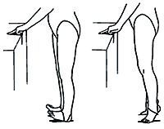  Elbow flexion  Assists with all daily activities.  - Turn palms up so facing ceiling  - Keeping upper arms on bed slowly bend BOTH elbows.  - Slowly straighten arm  - Repeat 10 times  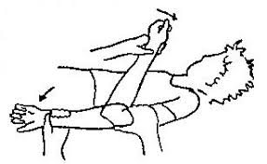  Standing leg Extension  This strengthens the muscles in the back of the leg and increases confidence with stepping backwards.  - Rest hands on chair  - Slowly kick right leg back, keeping knee straight  - It should be a small movement. If you start to lean forward you are kicking too far  - Do not let leg drop back to starting position, control its decent.  - Repeat 10 times with each leg.  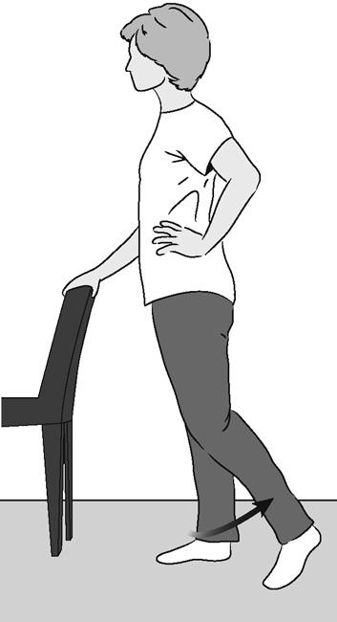 | Shoulder flexion  Increase arm strength with dressing, cleaning, cooking and reaching for objects overhead.  - Point thumb towards ceiling  - Slowly lift right arm over your head keeping elbow straight.  - Bring it back down to your side.  - Lift arm up over your head and back down.  - Go slow in both directions  - Repeat 10 times with each arm  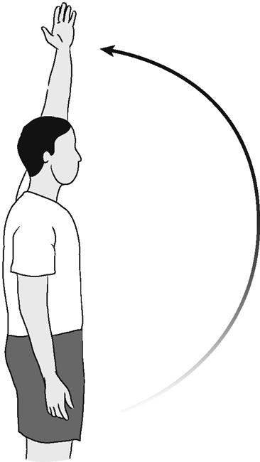  marching in place  Teaches weight shifting and standing on one foot which will help with walking.  - Rest hands on chair.  - Lift right knee up towards your chest and hold  - Slowly lower right leg. Do not let it drop on the floor  - Lift left knee up towards your chest and hold.  - Slowly lower left leg. Do not let it drop to the floor  - Control movement in both directions  - Keep back as straight as possible  - Repeat 10 times.  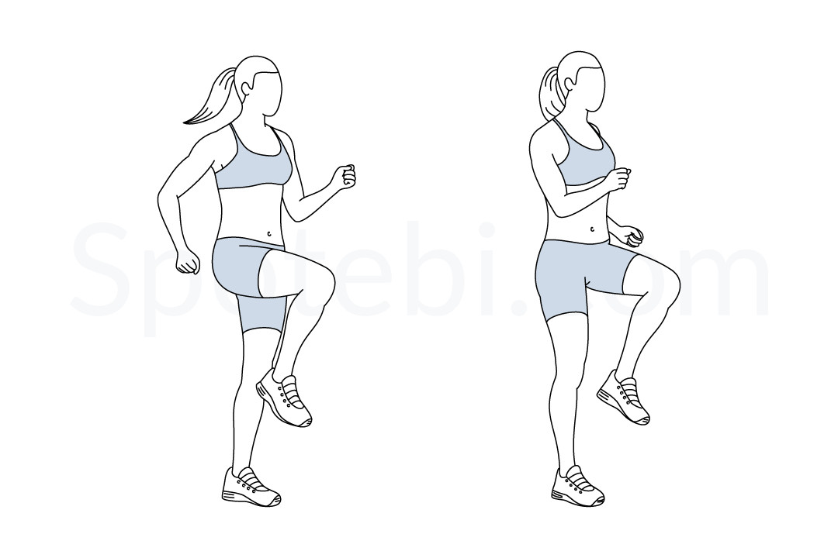  Standing hip abduction  Strengthens hip stabilizers that assist with walking.  - Rest hands on chair  - Kick leg out to side, keeping knee straight and toes pointed forward. Make sure the kick movements are side to side and not to the front or back.  - It should be small movements  - Do not let leg drop back to starting position, control its decent.  - Repeat 10 times with each leg  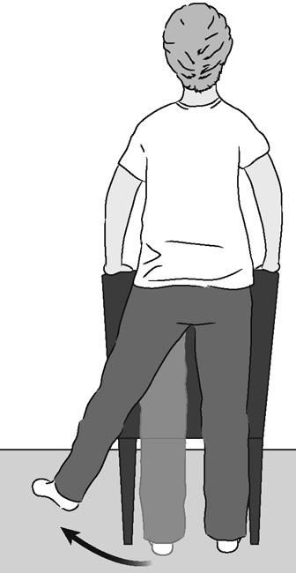
Other Safety Tips
- Keep emergency numbers in large print near each phone
- Put a phone near the floor in case you fall and can’t get up.
- Think about wearing an alarm device that will bring help in case you fall and can’t get up.

